Software Requirements Specification
for
Taxi Demand Prediction in New York City
Version 1.0 approved
Prepared by Yash Gupta(BT17CSE083) and Anikesh Pal(BT17CSE024)
Indian Institute of Information Technology, Nagpur
28-01-2019
Table of Contents
Table of Contents ii
Revision History ii
1. Introduction 1
1.1 Purpose 1
1.2 Document Conventions 1
1.3 Intended Audience and Reading Suggestions 1
1.4 Product Scope 1
1.5 References 1
2. Overall Description 1
2.1 Product Perspective 1
2.2 Product Functions 2
2.3 User Classes and Characteristics 2
2.4 Operating Environment 2
2.5 Design and Implementation Constraints 2
2.6 User Documentation 3
2.7 Assumptions and Dependencies 3
3. External Interface Requirements 3
3.1 User Interfaces 3
3.2 Hardware Interfaces 3
3.3 Software Interfaces 4
3.4 Communications Interfaces 4
4. System Features 4
4.1 Baseline Models 4
4.2 Regression Models 4
5. Other Nonfunctional Requirements 4
5.1 Performance Requirements 4
5.2 Safety Requirements 4
5.3 Security Requirements 5
5.4 Software Quality Attributes 5
5.5 Business Rules 5
6. Other Requirements 5
Appendix A: Glossary 5
Appendix B: Use Case Diagrams…………………………………………………………..……7
Appendix C: Supporting Images…………………………………………………………..… ...8

Revision History
Name | Date | Reason for Changes | Version

Introduction

Purpose
Product identified by this software requirement specification is Taxi demand prediction in New York city. This is the version 1 of the project and permissible for use to everyone giving proper credits.

Document Conventions
Standards and Typographical convention that were followed when writing this SRS are:
- Important points are highlighted or bolded and.
- Similar requirements may be repeated to specify the importance when needed.
- Every statement has its own priority until specifically mentioned.
- Few uncommon terms are explained at the end of document.

Intended Audience and Reading Suggestions
Audience for the SRS document is developers, project managers, marketing staff, project owner, users, testers and document writers. This document is meant to be read in the sequential manner while Appendix can be referred when needed.

Product Scope
Software is being designed for Taxi Drivers, including passengers (in some cases). This will help the Taxi Drivers find the suitable location for the maximum numbers of rides. While passengers who are facing difficulty booking the rides can book the rides from that location. Secondly, it will also help to increase the data base and location scope.

References
1) For Data - http://www.nyc.gov/html/tlc/html/about/trip_record_data.shtml

2) For Maps – Google Maps and www.nyc.gov

Overall Description

Product Perspective
This is new self-contained product targeting the new Taxi Drivers or Taxi Companies for getting the location of the maximum number of rides on average.
If the location is nearby driver can go that nearby location.

Product Functions
This is the machine learning and artificial intelligence model which will do the analysis of data from the official website using various techniques, then manipulating the data using the model requirements.
At the parallel time segmenting the New York City in smaller areas based on the frequency of the rides.
After this apply the data to segments using various model or the combination of model to deduce the not useful data to useful data.

User Classes and Characteristics
Product shall be used by both online and offline Taxi Drivers and Taxi companies. In the initial phase product will be Drivers specific but has the flexibility for increasing users like passengers of both local and tourist type.

Operating Environment
In the initial phase python will be the default programing language. Model will be made on the Jupyter Notebooks(.ipynb) while once the Models are made it can be extended to any python supporting platform like Windows, Linux, Mac, Android, ios etc.

Design and Implementation Constraints
Get the data from: http://www.nyc.gov/html/tlc/html/about/trip_record_data.shtml (2016 data) The data used in the attached datasets were collected and provided to the NYC Taxi and Limousine Commission (TLC).

Yellow Taxi: Yellow Medallion Taxicabs - These are the famous NYC yellow taxis that provide tran
sportation exclusively through street-hails. The number of taxicabs is limited by a finite number of medallions issued by the TLC. You access this mode of transportation by standing in the street and hailing an available taxi with your hand. The pickups are not pre-arranged.

Field Name | Description
VendorID | A code indicating the TPEP provider that provided the record.  - Creative Mobile Technologies  - VeriFone Inc.
tpep_pickup_datetime | The date and time when the meter was engaged.
tpep_dropoff_datetime | The date and time when the meter was disengaged.
Passenger_count | The number of passengers in the vehicle. This is a driver-entered value.
Trip_distance | The elapsed trip distance in miles reported by the taximeter.
Pickup_longitude | Longitude where the meter was engaged.
Pickup_latitude | Latitude where the meter was engaged.
RateCodeID | The final rate code in effect at the end of the trip.  - Standard rate  - JFK  - Newark  - Nassau or Westchester  - Negotiated fare  - Group ride
Store_and_fwd_flag | This flag indicates whether the trip record was held in vehicle memory before sending to the vendor,  aka “store and forward,” because the vehicle did not have a connection to the server.  Y= store and forward trip  N= not a store and forward trip

User Documentation
Product is pretty much straight forward. In the initial phase only, the models are made on the approximately 6-7 Gigabytes of data only but has the future plans of upgrading it to 60-70 Gigabytes of free data available on www.nyc.gov website and counting.
User manual, on-line help, off-line help and tutorials can be provided on demand.

Assumptions and Dependencies
Assumption made while making the project is that Jupyter notebooks is install on the user’s side.
As Python and Jupyter notebooks both are open source no extra investments are needed on operating environment from user.

External Interface Requirements

User Interfaces
Initial Standard Jupyter Notebooks GUI will be the interface of user and developer both. Later version will have a support for non-programming environment for users.

Hardware Interfaces
Development of Model will be done on –
Processor – Intel(R) Core(TM) i5-7200U CPU @ 2.50GHz 2.70 GHz
Installed memory (RAM) – 8.00 GB
System type – 64-bit Operating System, x64-based processor
Secondary storage - WD Green 120GB Internal Solid-State Drive

Software Interfaces
Software Used for the Development of Model and testing –
Operating System – Microsoft Windows 10
Data Format - .csv file
Data analysis in Raw format – Microsoft excel
Language & Frameworks – Python & NumPy, Matplotlib, Sklearn, Seaborn, Pandas, Dask
IDE – Jupyter Notebooks (Anaconda)

Communications Interfaces
This project in the initial phase doesn’t come with the any communication device has potential to upgrade to web browsers, Servers, Mobile Apps etc.

System Features
After the Manipulation on data Resultant data is ready for making different models. Based upon the needed of the user and developers comfort Baseline Models and Regression Models can provide the best suit for this problem.

Baseline Model
Sub models made are Ratio & Previous Time Bin Values, Simple Moving Averages, Exponential Weighted Moving Average, Weighted Moving averages.

Regression Models
Sub models are Train Test Split & Features, Linear Regression, Random Forest Regression, XGBoost Regression, Model Comparison.

Other Nonfunctional Requirements

Performance Requirements
Performance of the training of model is dependent on the hardware used. Different Models have different training time but after model making request from model can be deal in significantly less time.

Safety Requirements
Running project on lower hardware device may result in crashing of software like Jupyter notebooks still unaffected on the operating system. This is mainly due to low RAM in initial modeling to prevent “DASK” framework of python.

Security Requirements
User data security is the main issue in the case of Machine Learning project. Data used is from official New York City government (USA) which is open to use for the educational purpose. A full functional version of the project may include the permissions which need to granted to program before proceeding.

Software Quality Attributes
Software is highly adaptable with system having python installed. Also, extremely portable. It may require little programming knowledge to use in the initial phase but later version shall provide user friendly experience.

Business Rules
Anyone can use the project for commercial and non-commercial purpose. All the software used to make the project are open source.

Other Requirements
Appendix A: Glossary
Dask - Dask is a flexible library for parallel computing in Python.
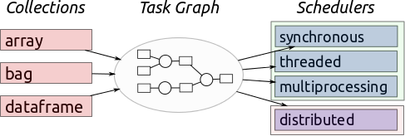
Project Owner – Person or Organization for whom project is being develop

Appendix B: Use Case Diagram
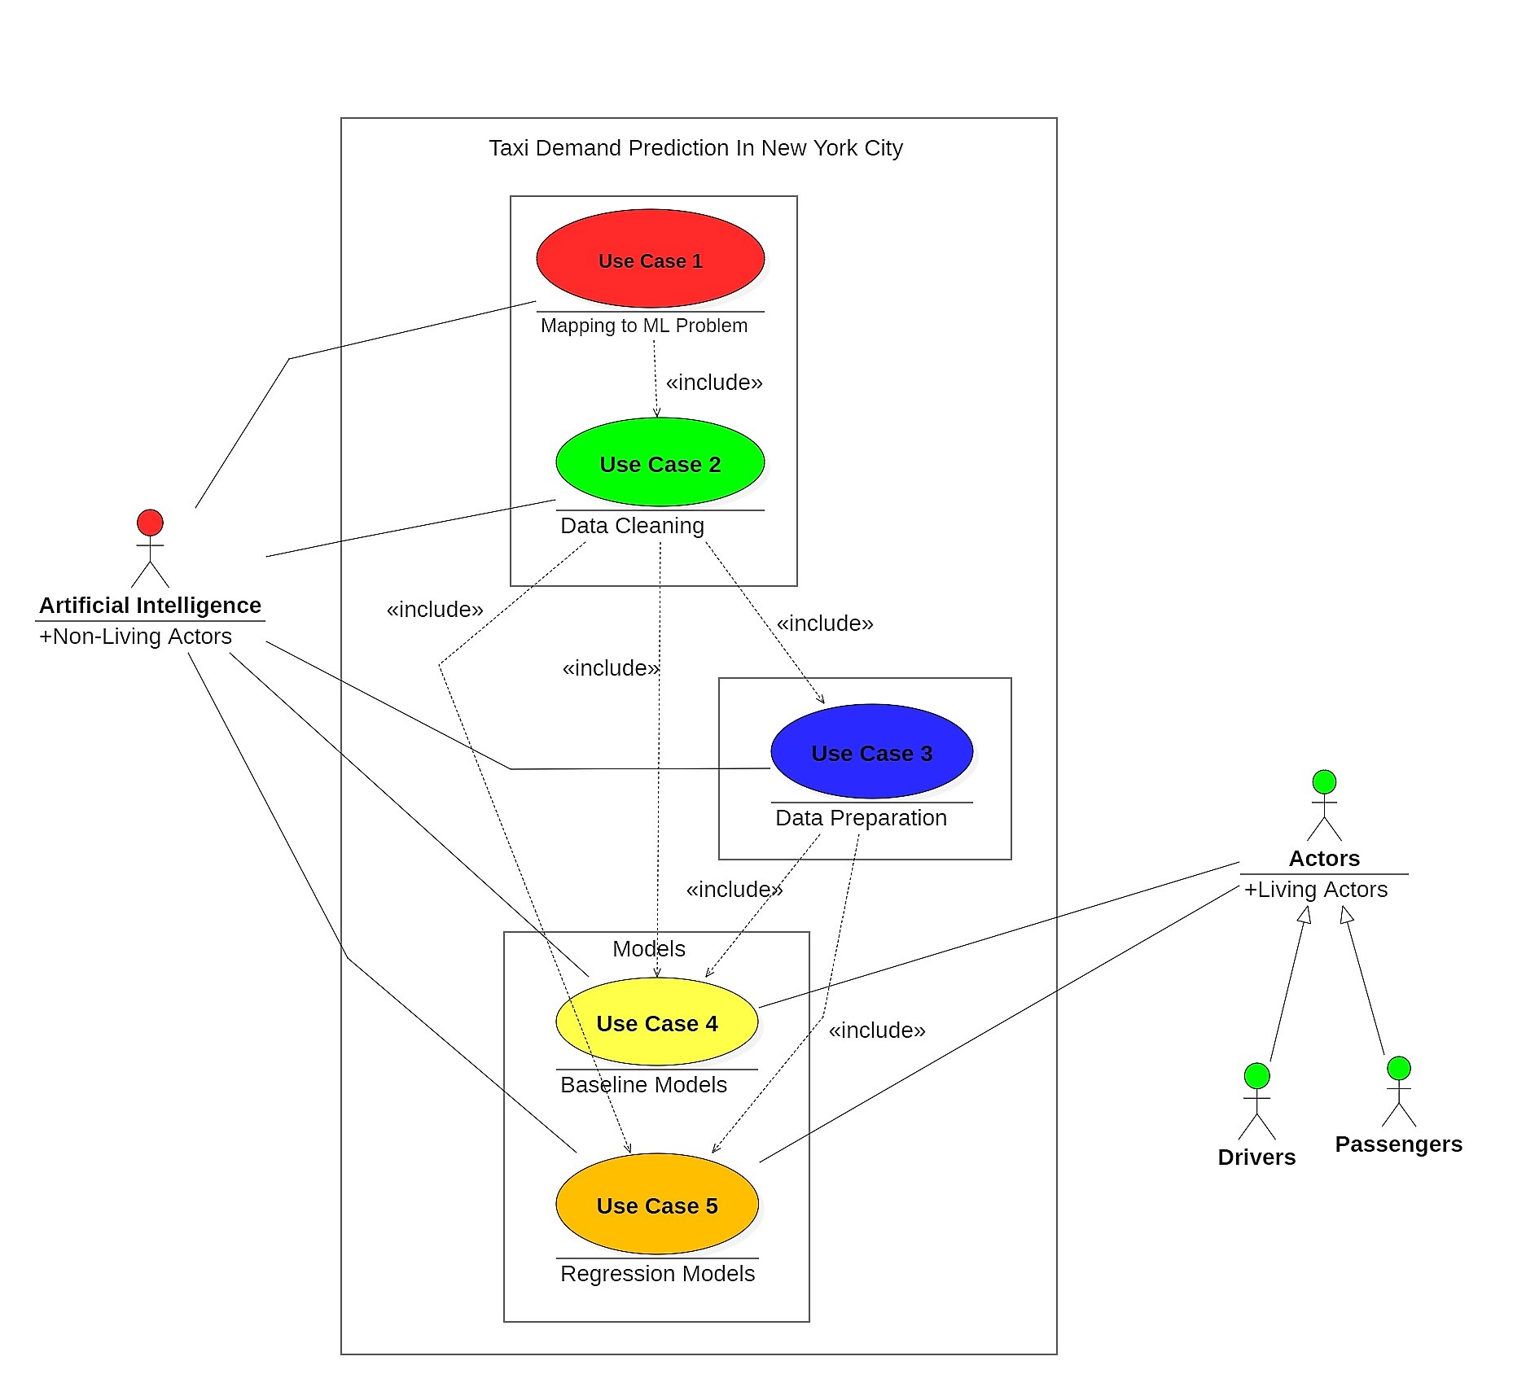
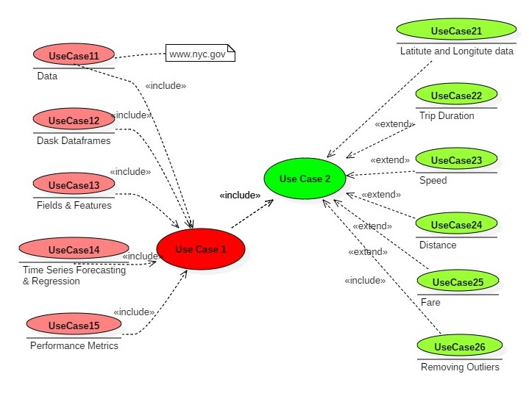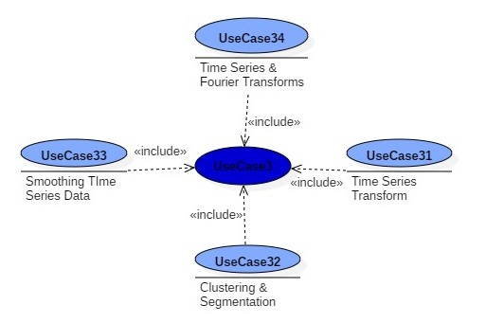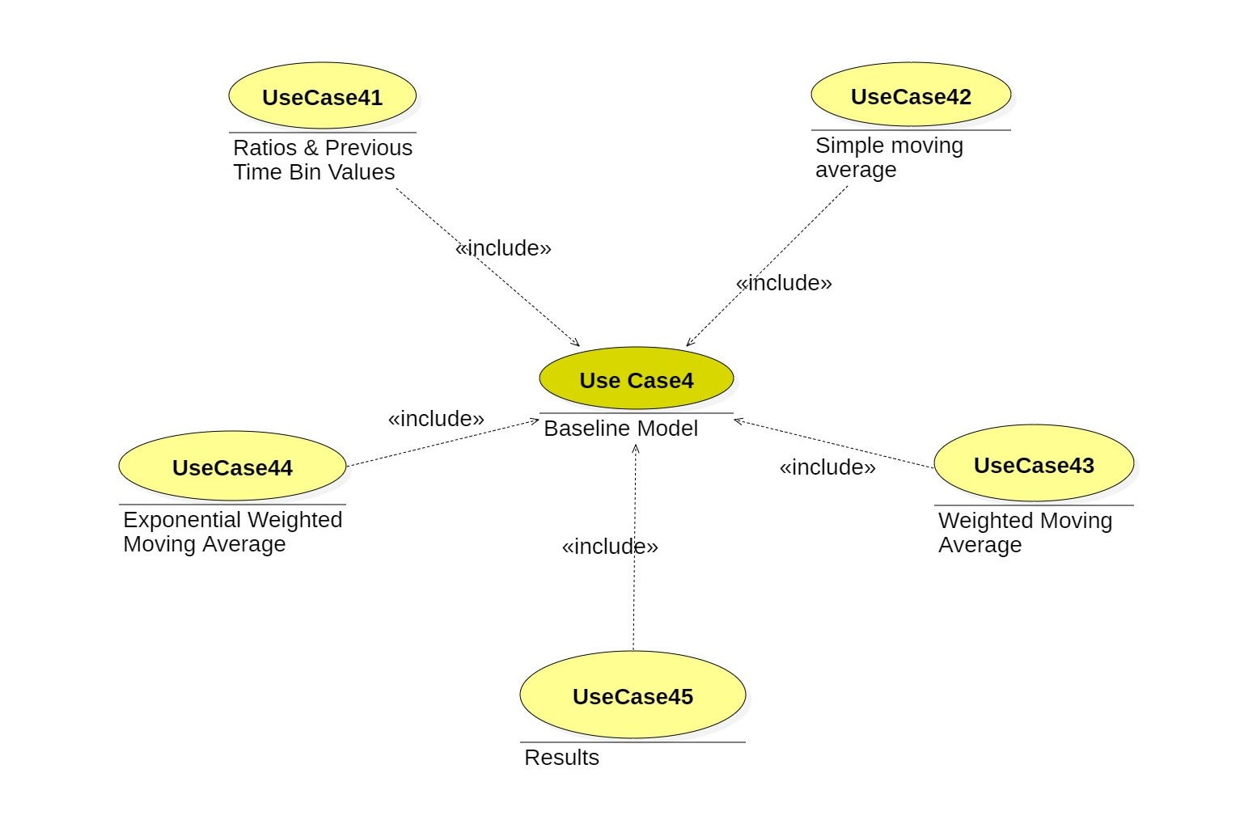
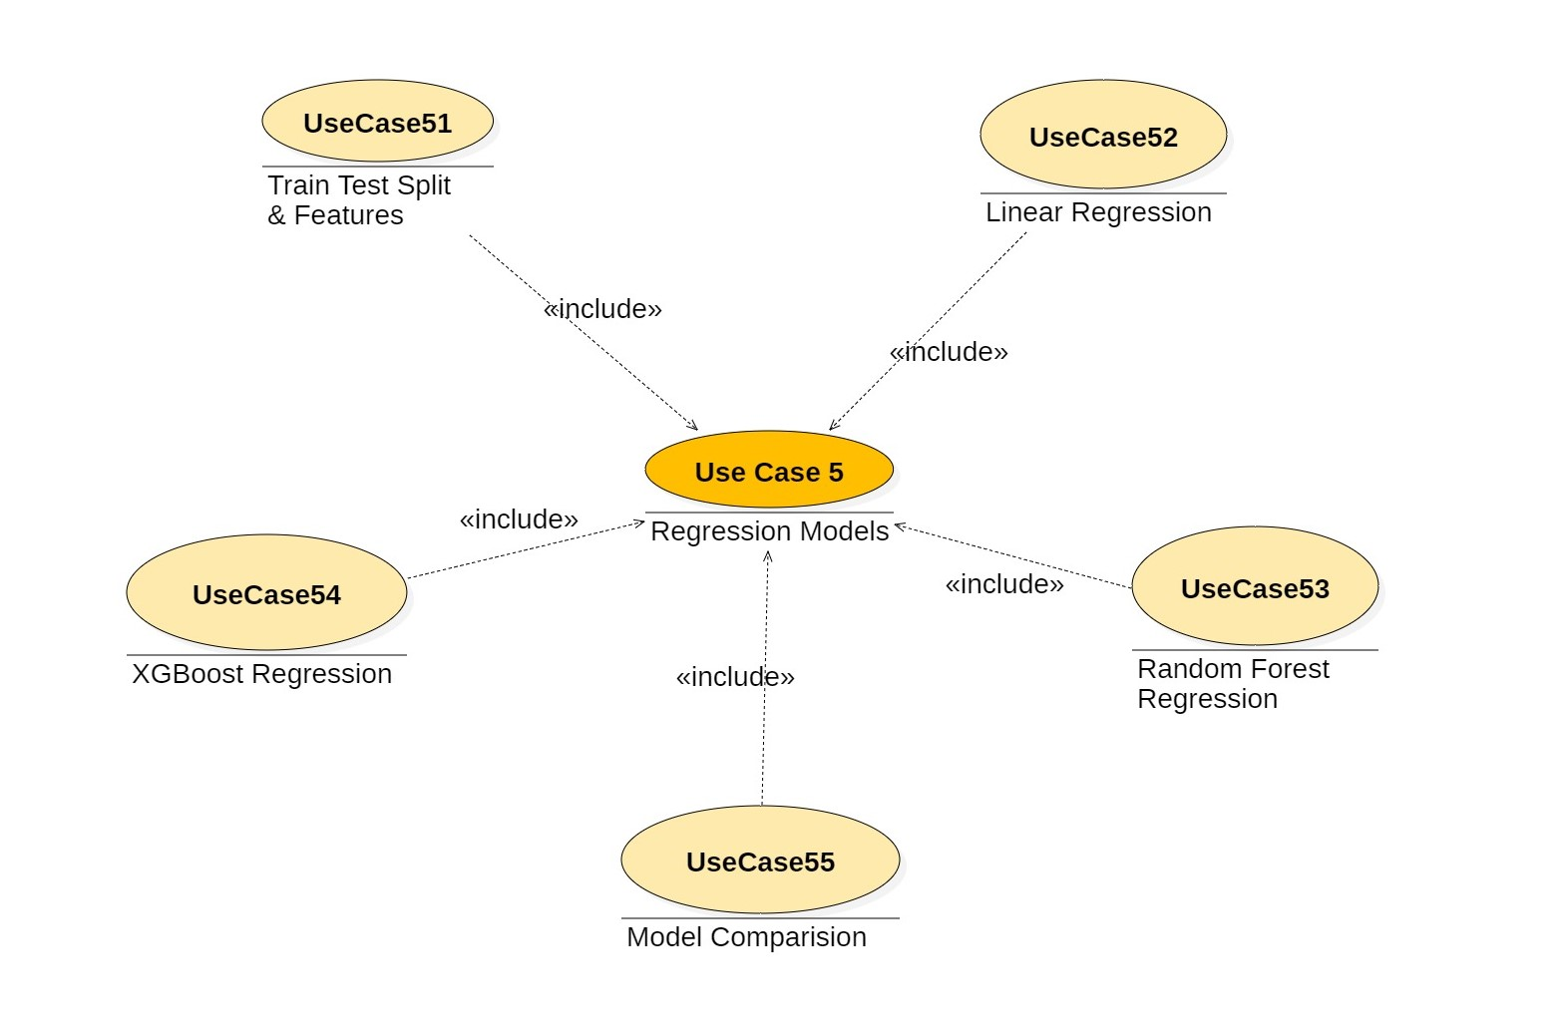
Appendix C: Supporting Images
